Litigation Against Environmental Rollbacks in the Trump Administration

Supplemental Materials Presented by Stacey Geis, Managing Attorney at Earthjustice
LITIGATION:
To date, Earthjustice has brought 130 lawsuits against the Trump Administration, on behalf of over 160 different partners. 40 of those cases have been decided on the merits, and Earthjustice and its clients have won 33 of them to date.
According to Prof. Bethany Davis Noll, Institute of Policy Integrity at NYU School of Law, to date, the Trump Administration’s win record is 6%. www.policyintegrity.org/trump-court-roundup. That is for all legal challenges brought against the Trump Administration for agency policy decisions. To provide context, on average, according to Prof. Davis Noll, federal administrations that face legal challenges to agency action win approximately 70% of the time. The majority of the successful legal challenges involve rollbacks of environmental protections, but there also have been cases involving health care (2nd place), immigration, consumer protection, education, housing, workers and discrimination, and agriculture. Of these successful legal challenges against the Trump Administration, 75% were won in courts; 25% resulted in the Administration withdrawing the challenged action post-filing by the plaintiffs.
In order of likelihood of success, the Trump Administration loses in court because of:
  - Statutory authority or a statute violated
  - Failure to provide reasoned explanations
  - Failure to provide notice and comment
  - Improper analysis of harms/forgone benefits
    - E.g., Risk Management Rule, Effluents Rule, BLM Methane Rule
  - Violated regulations
  - Failure to provide proper environmental review
Trump federal judiciary appointments:
To date, Trump has appointed 187 Article III judges. 2 Supreme Court justices; 50 circuit judges; and 133 district court judges. en.wikipedia.org/wiki/List_of_federal_judges_appointed_by_Donald_Trump). In eight years, Obama appointed 2 Supreme Court justices; 55 circuit judges; and 268 district judges. Because of the Senate’s stonewalling of Obama nominees in the 114th Congress, when Trump took office, there were 104 empty Article III seats, including : 1 Supreme Court seat (Garland); 17 circuit judge seats and 86 district court seats, which in part set the stage for the significant number of Trump appointments in such a short period of time. www.uscourts.gov/judges-judgeships/judicial-vacancies/archive-judicial-vacancies/2017/01/summary
For context, right now, ¼ of all current active circuit judges, which Justice Sotomayor once noted as a district judge is “where policy is made,” are Trump appointees. https://www.vox.com/policy-and-politics/2019/12/9/20962980/trump-supreme-court-federal-judges. As of Sept. 2019, 78% of Trump appointees are men and 86% are white. The average age of Trump appointee is less than 50 (49.65 y/o as of 9/19), which is ten years younger than the average age of an Obama appointee.
SELECTED EARTHJUSTICE PRESS RELEASES AND ARTICLES:
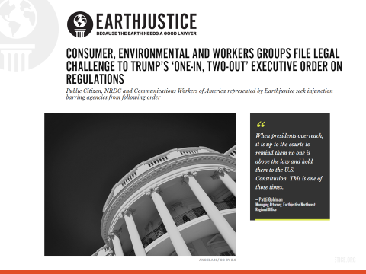
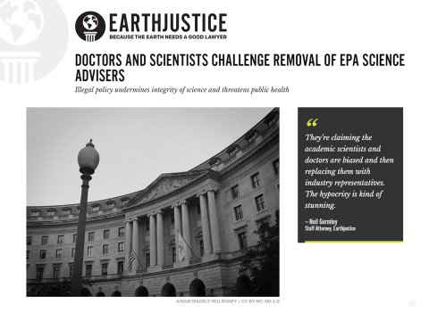

COURT RULES THAT EPA UNLAWFULLY EVALUATED CHEMICAL RISKS TO COMMUNITIES
Victory: The agency must now make important changes to consider the full range of exposures and risks
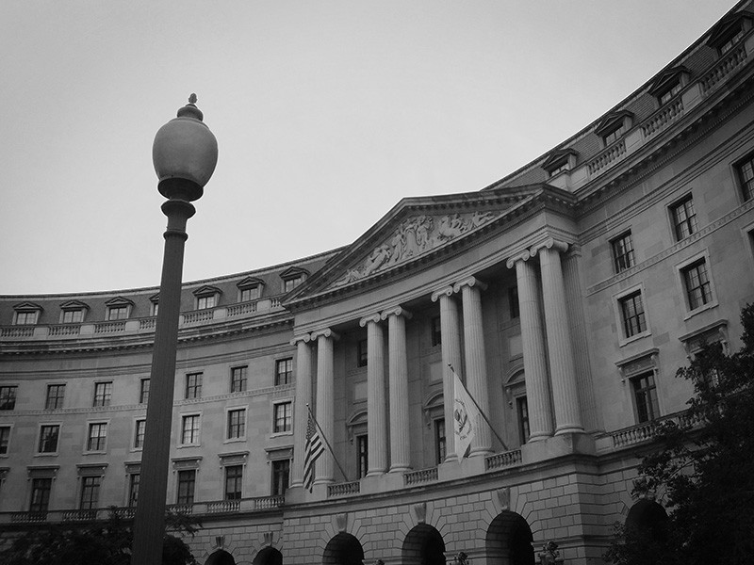
The U.S. EPA’s flag flies outside the Federal Triangle complex in Washington, D.C.
NOVEMBER 18, 2019
San Francisco, CA —
Last week, the 9th Circuit Court of Appeals issued a ruling for Safer Chemicals Healthy Families, et al v. U.S. EPA that will control key aspects of how the Environmental Protection Agency (EPA) evaluates the risks of chemicals under the federal law known as the Toxic Substances Control Act (TSCA). TSCA was enacted to give EPA authority to look comprehensively at the hazards associated with chemicals in order to prevent harm to health and the environment through regulation of chemicals that pose unreasonable risks. Nonetheless, the vast majority of chemicals in commerce have never been reviewed by EPA for safety and remain unregulated.
This near-total failure to address chemical risks led Congress to amend TSCA in 2016, establishing a mandatory process to systematically evaluate and manage the risks of existing chemicals. To implement this new mandate, Congress required EPA to issue two rules, known as the Framework Rules, establishing the processes by which EPA will prioritize chemicals for risk evaluations and then conduct those evaluations. These rules were adopted by the Trump administration, under the direction of a former chemical industry lobbyist, in order to stack the deck in favor of chemical companies. This lawsuit challenged the legality of the Framework Rules, seeking to ensure that EPA’s approach to chemicals protects people and the environment, not chemical company profits. The court postponed decision on some of the issues in the case, and issued critical rulings on others.
As a result of last week’s ruling, EPA must make important changes into how it is evaluating chemical risks, compelling it to consider the full range of ways that people may be exposed to harmful chemicals. First, the court ruled that EPA’s risk evaluations must be based on the ways people are being exposed to and harmed by chemicals still in use and still being disposed of, even if certain products containing the chemical are no longer being newly manufactured. For example, EPA must now take into account the risks to construction workers and firefighters demolishing or repairing buildings with asbestos in them, and the risks to children from drinking water contaminated by lead pipes (even though asbestos and lead are no longer made for these purposes).
Second, the court held that EPA’s rules “unambiguously do not grant EPA the discretion” to exclude exposure pathways from its risk evaluations. This means that EPA cannot pick some of a chemical’s uses to evaluate, and ignore others. While this case has been pending EPA has been conducting risk evaluations of ten chemicals, including asbestos. Preliminary documents show that EPA has been ignoring a wide range of chemical exposures, like workplace exposures and exposures to chemicals from drinking water. Under the court’s ruling, EPA’s rules do not give EPA discretion to ignore those uses, and EPA must therefore revamp its current approach and consider all of a chemical’s uses in each risk evaluation.
Statement of Eve Gartner and Tosh Sagar, attorneys at Earthjustice:
“The Court’s ruling means that the Trump administration’s attempt to stack the deck in favor of the chemical industry with a risk evaluation process that ignores the reality of how people are exposed to toxic chemicals has failed. EPA now must follow the law and assess real-world chemical risks, based on all exposure pathways, and restrict the chemicals that pose unreasonable risks based on this exacting review.”
Earthjustice filed this case on behalf of: Alaska Community Action on Toxics, Environmental Health Strategy Center, Environmental Working Group, Learning Disabilities Association of America, Sierra Club, Union of Concerned Scientists, and We Act for Environmental Justice. Additional petitioners in the consolidated lawsuit include: Natural Resources Defense Council, the Alliance of Nurses for Healthy Environments and Cape Fear River Watch, United Steel, Paper and Forestry, Rubber, Manufacturing, Energy, Allied Industrial and Service Workers International Union, AFL-CIO/CLC, Safer Chemicals, Healthy Families, Vermont Public Interest Research Group and the Asbestos Disease Awareness Organization and, the Environmental Defense Fund.

TRUMP’S EPA REVOKED CHEMICAL DISASTER PREVENTION RULES. NOW GROUPS ARE SUING.
Communities in chemical danger zones fight back against EPA’s latest attack on public health
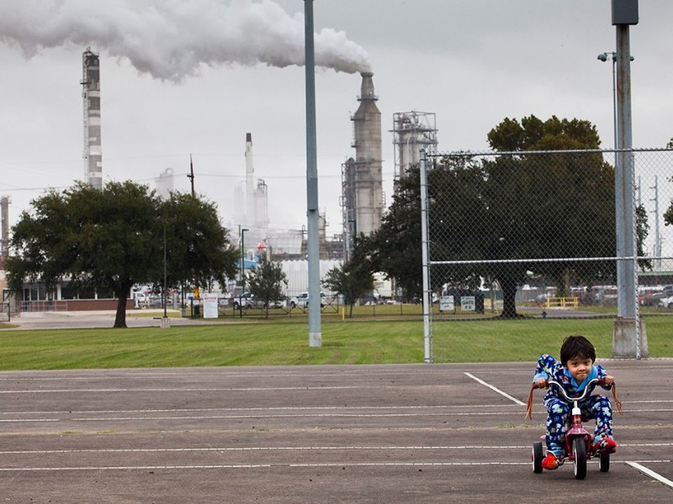
Chrisangel Nieto, 3, rides his tricycle in Hartman Park, the Manchester neighborhood of Houston, Texas. Nearly 180 million Americans live in the worst-case scenario zones for a chemical disaster, and at least one in three children go to a school near a hazardous chemical facility.
DECEMBER 19, 2019
Washington, D.C. —
Today, a coalition of thirteen organizations represented by Earthjustice sued the Trump administration for the unlawful gutting of the Chemical Disaster Rule, a suite of disaster prevention measures developed by the Environmental Protection Agency (EPA) in the wake of several deadly explosions and major chemical releases. Advocates across the country have been fighting for years to obtain these protections, which are now being eliminated despite mounting evidence of the danger communities face from chemical disasters.
EPA put the Chemical Disaster Rule in place to strengthen chemical plants’ prevention and preparedness requirements for explosions and other catastrophes, ensure better and more frequent coordination with first responders, and bolster community access to information about the chemical hazards they live next to. But since entering office, the Trump administration has sought to repeal, stall, or weaken these protections. The administration illegally delayed the rule for more than a year — a move that was struck down in court thanks to a lawsuit Earthjustice litigated. Now EPA has “amended” the rule to eliminate virtually all disaster-prevention measures it established and weaken many other protections.
“By killing these critical protections, millions of people living near chemical facilities in the United States are put in harm’s way. We are fighting for the lives and safety of our families and workers. Our lives are more valuable than the bottom line of a few chemical barons,” said the coalition defending the rule.
When developing the rule, EPA determined that prior protections failed to prevent over 2,200 chemical fires, explosions, leaks, and similar incidents during a 10-year period, including over 100 per year that caused injuries. EPA also said the Chemical Disaster Rule’s protections are needed to save the lives of workers, first-responders, and fence line community residents.
“The EPA’s rollback of life-saving components of the Chemical Disaster Rule is not just unlawful, it is irresponsible,” said Earthjustice attorney Emma Cheuse. “Instead, EPA should do its job and ensure that chemical companies do everything in their power to keep surrounding communities safe, and avoid a worst-case scenario. Now that Trump’s EPA has decided to try again to gut these protections, and put chemical companies’ preferences over the safety of children in danger zones, we have no choice but to go to court.”
The lawsuit comes just weeks after a chemical plant exploded in Port Neches, Texas, displacing some 50,000 people and injuring eight others as the fire sent toxic plumes of 1,3-butadiene and other carcinogens into the air. This facility is covered by the current Chemical Disaster Rule. Without the Chemical Disaster Rule, this plant won’t have to conduct an assessment of safer alternatives for the plants’ operations, be subject to an independent safety audit, apply lessons learned from this incident to prevent future problems, or even train all supervisors responsible for managing dangerous chemical processes. Contrary to EPA’s justification for repealing these safety rules, prior enforcement at this very facility under the pre-existing regulatory framework failed to prevent this disaster which made children miss school, and continued to require shelter-in-place a week after the incident to try to reduce toxic exposure.
THE GUARDIAN
Thousands evacuated after a series of explosions took place at the Port Neches chemical plant in Texas.
Nearly 180 million Americans live in the worst-case scenario zones for a chemical disaster. At least one in three children go to a school near a hazardous chemical facility. About 12,500 industrial facilities nationwide use, store, or manage highly hazardous chemicals that the Chemical Disaster Rule covers. EPA’s new attack on the Chemical Disaster Rule comes some two years after EPA illegally suspended the rule to try to prevent it from taking effect. Following a lawsuit in which Earthjustice represented communities from around the country affected by chemical disasters, and in which the United Steelworkers Union and eleven states also participated, a federal court reinstated the rule and said EPA’s suspension made “a mockery of the statute.” EPA did not appeal that ruling.
Earthjustice is representing Union of Concerned Scientists, Environmental Integrity Project, Sierra Club, Coalition For A Safe Environment (Wilmington, CA), California Communities Against Toxics, Del Amo Action Committee, Louisiana Bucket Brigade, Air Alliance Houston, Community In-Power & Development Association (Port Arthur, TX), Texas Environmental Justice Advocacy Services, Clean Air Council (Philadelphia, PA), Utah Physicians for a Healthy Environment, and Ohio Valley Environmental Coalition (West Virginia).

